TITLE OF THE PAPER in 12 point tIMES NEW rOMAN with boldface capital
First A Author*¹, Second B Author² and Third C Author³
¹ Author’s Position, University/Institute/Organization, Country, e-mail: xx1@yy1.com
² Author’s Position, University/Institute/Organization, Country, e-mail: xx2@yy2.com
³ Author’s Position, University/Institute/Organization, Country, e-mail: xx3@yy4.com
*Corresponding Author
ABSTRACT
The paper should be written in English using MS Word. The header at the top of the first page should be different from other pages as shown in this template. The authors should use this template to prepare the manuscript. Times New Roman is the accepted typeface for the paper.

The title of the paper should be at the top of the page at 12-point Times New Roman with BOLDFACE CAPITAL.

The names of authors shall follow the title with a paragraph space of 24-point before and 12-point after the author list, as shown. The names should be separated by comma with numbering as above. Please DO NOT use any salutation (e.g. Professor, Dr., Mr., Ms. etc.) with the authors’ names.

The corresponding/presenting author should be denoted by an asterisk (*) and should be placed after the author(s) affiliation/address with a space of 6-point before it. The affiliation/ address of the authors should follow the author list after a single line space.

The Abstract heading should be 11-point Times New Roman typeface or an equivalent, in BOLDFACE CAPITAL. The abstract should be formatted in 11-point Times New Roman font with single-line spacing.

For IICASD-2024, we would like to request author(s) to extend the abstract in the full paper (called as Extended Abstracts) which will allow us to provide a more detailed synopsis of the paper in the ‘Volume of Abstracts’. The Abstract (in extended form) should be self-contained and explicit, setting out the ground covered, brief methodology and the principal conclusions reached. The Abstract can also contain major results.

The (extended) Abstract MUST NOT exceed beyond the first page (including the list of Keywords) and the main text of the paper MUST start on the next page, i.e. the first page should only contain the title, list of authors and their affiliations, abstract and keywords. No figures and tables should be included in the abstract section. The Abstract should be formatted as 11-point Times New Roman, fully justified.

The number of keywords should be limited to 5 and should be formatted in 11-point Times New Roman Italic font, fully justified.

Keywords: Title, abstract, objective, results, conclusions

- IntroductioN
The main text MUST start on the second page of the paper. The first page must only contain the title, list of authors and their affiliations, (extended) abstract and list of keywords.

It is better if someone starts to work on the paper by writing on this template. Using this template will help ensure that paper styles comply with IICASD-2024 requirements. Thus, the author will have all the styles already created and ensure a properly formatted document. Authors' failure to follow the proper formatting may cause rejection for publication by the formatting editor. This template is available for download at the conference website.

For all texts, 11-point Times New Roman font in single spacing without any indent and fully justified is recommended. Manuscripts must be typed on an A4-sized page; margins should be 1 inch (25mm) left, right, top and bottom. Do not leave space at the top of a page. The paper MUST NOT exceed 12 pages in length including (extended) abstract, text, figures, tables, acknowledgments and references. The paper must be submitted electronically at the “Submission” page of the conference website www.iicasd.com before the submission DEADLINE as indicated in the conference website.
- methodology
For all headings Arabic numbers should be used; aligned with the left-hand margin. We recommend for major headings 11-point Times New Roman typeface. The major headings are formatted as this document in 11-point BOLDFACE CAPITAL with 24-pt space before and 6-pt space after.

In-text citations and references should follow the American Psychological Association (APA) referencing style. References are to be listed at the end of the paper in alphabetical order of the last names of the first authors and citation in the text by the last name and the year of publication within parentheses (e.g., Santhanam, 1998; Martin et al., 2000; Goody & Hicks, 2001). A complete list of examples following APA style is also available for download at the conference website. Try to follow the styles of that document as closely as possible.
- The 1st Sub-heading
For Subheading 1, we recommend 11-point Times New Roman typeface or an equivalent and boldface letter with 10pt space before and 5pt space after. The text of the headings should be typed in title case (i.e., using capital letters as 1st letter of each word). The authors are advised to follow the style used in this document.
- The 2nd Sub-heading
This section is to demonstrate the relative position of the subsections led by sub-headings. The 2nd Sub-heading is similar to the 1st Sub-heading. The text of the headings should be typed in title case (i.e., using capital letters as 1st letter of each word).
- This is a typical level-3 heading
It is advised not to use more than two levels of sub-headings unless otherwise necessary. However, for the 3rd Sub-heading, if any, 11-point Times New Roman typeface or an equivalent, boldface and italic letters with 10 pt space before and 5pt after are recommended.
- Illustrations
- Figures and Graphs
All figures, photographs and illustrations should be rich in contrast and clearly distinguishable from each other when they are printed in black and white. The figures/graphs, tables and equations should be explicitly mentioned in the text. The placement should be as close as possible to the text block in which it is first mentioned (preferably within the same page and if not possible to the very next page). Use “In line with Text” format as Wrap Text for figures/graphs. Centre captions directly below the figure. The figure/graph is followed by a single blank line as illustrated here. Reduce the picture size to “Document Resolution” to compress any image after placement to reduce the overall file size.

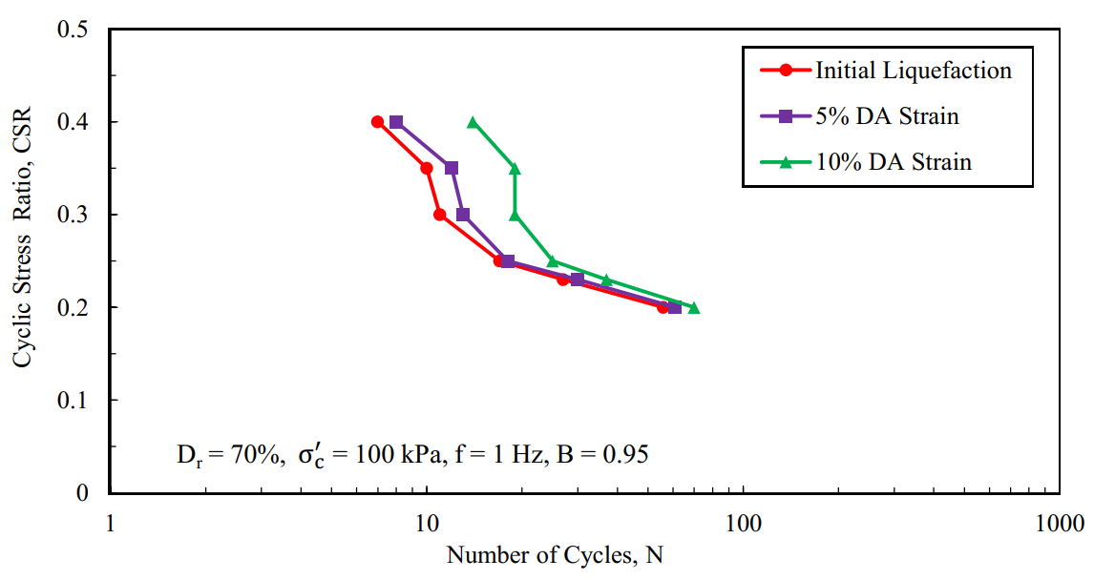

Figure 1: Example for figure title
- Equations
Equations must be with italic letters and aligned left-hand with the text margin and should be preceded and followed by a blank line.

$−\overline{u_{i}u_{j}}=ν_{t}S_{\text{ij}}−\frac{2}{3}{kδ}_{\text{ij}}−\frac{k}{ε}v_{t}\sum_{β=1}^{3}{c_{β}\left(S_{β\text{ij}}−\frac{1}{3}S_{\text{βαα}}δ_{\text{ij}}\right)}$ (1)

Numbers in equations should be numbered with the right-hand margin aligned and enclosed in brackets. Mention equation (X) when referring to equations in the text.
- Tables
All tables are to be in black and white and should be placed as close to their mention in the text as Table X. Centre captions preferably directly above the table being described. Tables MUST NOT contain any vertical lines.

Table 1: Example table

Margin | Top | Bottom | Left | Right
1 inch | 1 inch | 1 inch | 1 inch | 1 inch

- CONCLUSIONS
Please provide a brief conclusion based on the results and discussions.
ACKNOWLEDGMENTS
Place to acknowledge the contributions of persons or institutions which were crucial in finishing the paper, if any. This section, if appears, is expected to be limited to 4 lines.
REFERENCES
Graves, A.L. and Gooch, R.S. (1986), “Central Arizona Project Start Up.” Proceedings of the Water Forum '86: World Water Issues in Evolution. ASCE, New York, N.Y., Vol. 1, 546-551.
Marsh, A., and Viglione, D. J. (1992), A Conceptual validation study of the texture response on the Rorschach. Journal of Personality Assessment, 58(3), 571-579.
O’Donoghue, T., and Clarke, S. (2010). Leading learning: Process, themes and issues in international contexts. London: Routledge.
Dandy, E., Martin, K., Goody, A., and Hicks, O. (2011), Bottom-up steps towards closing the loop in feedback on teaching: A CUTSD project. Paper presented at Teaching and Learning Forum – Expanding horizons in teaching and learning, Perth, Australia, 7-9 February 2001.

